MEMORANDUM
No.____ __ s. 2026
TO: VICE PRESIDENTS
CHIEF ADMINISTRATIVE OFFICERS
COLLEGE DEANS
DIRECTORS
UNIT HEADS
NON-TEACHING PERSONNEL
ALL CONCERNED
FROM: OFFICE OF THE UNIVERSITY PRESIDENT
DATE: FEBRUARY 2, 2026
SUBJECT: FY 2026 INIDIVIDUAL PERFORMANCE COMMITMENT AND REVIEW (IPCR) GUIDELINES FOR NON-TEACHING PERSONNEL

- Background

The FY 2026 Individual Performance Commitment and Review (IPCR) Guidelines are hereby issued pursuant to the approved Strategic Performance Management System (SPMS) of Partido State University, as duly approved by the Board of Regents (BOR) and the Civil Service Commission (CSC), in accordance with CSC Memorandum Circular No. 6, s. 2012, and other applicable civil service laws, rules, and issuances. The SPMS serves as the official and exclusive performance management framework of the University and governs the planning, monitoring, evaluation, and recognition of performance at the institutional, office, and individual levels

These Guidelines are promulgated to operationalize the SPMS for Fiscal Year 2026 by prescribing uniform, objective, and enforceable standards and procedures for the preparation, implementation, and evaluation of Individual Performance Commitment and Review (IPCR) forms. They provide the formal mechanism by which individual employees, teaching and non-teaching, translate office-level commitments into specific, measurable, and accountable deliverables, supported by verifiable means of verification, and aligned with approved performance indicators

The IPCR Guidelines are intrinsically linked to, and derived from, the FY 2026 Office Performance Commitment and Review (OPCR) Guidelines. As such, they form part of a single, coherent performance management continuum under the SPMS. While the OPCR establishes collective accountability at the office level, the IPCR institutionalizes individual accountability by ensuring that every employee’s outputs directly contribute to the attainment of office deliverables and, ultimately, to the realization of institutional goals

A fundamental basis of these Guidelines is the Institutional Deliverables Pathway. This pathway defines the structured cascading of performance obligations within the University. Institutional Deliverables, anchored on national and regional directives, presidential instructions, the BOR-approved University Strategic Plan, and congress-approved physical targets, are translated into Departmental (Vice President-Level) Deliverables, then disaggregated into Office Deliverables through the OPCR. These office-level commitments are further cascaded into Individual Deliverables through the IPCR, ensuring vertical and horizontal alignment of performance across all organizational levels

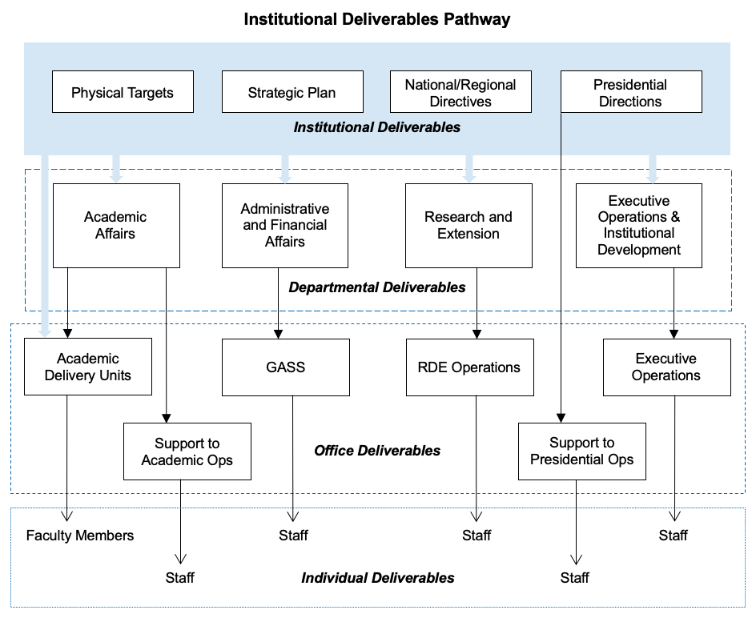
Figure 1. Institutional Deliverable Pathway

Through this cascading mechanism, the IPCR ensures that individual performance is not evaluated in isolation but assessed in direct relation to the office mandates, strategic priorities, and operational responsibilities assigned under the OPCR. This alignment safeguards coherence between institutional planning, budget utilization, and personnel accountability, and prevents fragmentation or duplication of efforts across offices and units.

Accordingly, the FY 2026 IPCR Guidelines are issued to:

- institutionalize standardized procedures for individual performance planning, monitoring, and review;
- ensure consistency and alignment between individual commitments, office targets, and institutional priorities; and
- establish a transparent, objective, and legally defensible basis for evaluating individual performance.

The results of IPCR evaluation shall serve as a primary basis for performance-based incentives, rewards and recognition, learning and development interventions, and other human resource actions under the SPMS.

These Guidelines shall form part of the mandatory implementation instruments of the SPMS for FY 2026 and shall be strictly observed by all covered personnel, subject to the authority of the Board of Regents and the regulatory oversight of the Civil Service Commission.
- SPMS Calendar

Activity | Deadline per Rating Period
 | Jan – Jun, 2026 | Jul – Dec, 2026
For Individual Performance Commitment and Review (IPCR)
Employee submits the signed Individual Performance Commitment and Review (IPCR) to the Immediate Supervisor (Directors/CAOs/College Deans). | February 13 | July 24
Immediate Supervisor signs the IPCR and transmits the same to the respective Vice President for signature. | February 16 | July 27
Vice President signs the IPCR and informs the concerned office/college of its availability for retrieval. | February 18 | July 29
Office/College retrieves the signed IPCR and transmits it to the Human Resource Management Unit (HRMU) Offices for safekeeping. | February 19 | July 31
IPCRs are retrieved from the HRMU Offices for use during the performance evaluation period. | June 15 | December 15
Employee submits the accomplished IPCR to the Immediate Supervisor (Directors/CAOs/College Deans). | July 1 | January 4, 2027
Immediate Supervisors convene the office/college-level IPCR Evaluation Committee to evaluate the accomplished IPCRs. | July 2 | January 5, 2027
Immediate Supervisor signs the validated IPCR and transmits the same to the respective Vice President for signature. | July 6 | January 7, 2027
Vice President signs the validated IPCR and informs the concerned office/college of its availability for retrieval. | July 8 | January 11, 2027
Office/College retrieves the validated IPCR and transmits it to the HRMU Offices for record keeping. | July 9 | January 12, 2027
Human Resource Management Unit (HRMU) Offices prepare and submit the summary of IPCR ratings to the Performance Management Team (PMT) Secretariat. | July 10 | January 13, 2027
For Office Performance Commitment and Review (OPCR)
Director/CAO/College Dean submits the Office Performance Commitment and Review (OPCR) to the respective Vice President. | February 17 | July 24
Vice President signs the OPCR and endorses the same to the Performance Management Team (PMT) Secretariat. | February 18 | July 27
PMT Secretariat checks the OPCR and endorses it for the signature of the University President. | February 18 | July 28
University President signs the OPCR and informs the PMT Secretariat of its availability for retrieval. | February 20 | July 29
PMT Secretariat retrieves the signed OPCR and transmits it to the Institutional Planning and Development Office (IPDO) for safekeeping. | February 20 | July 30
OPCRs are retrieved from the Institutional Planning and Development Office (IPDO) for use during the performance evaluation period. | June 15 | December 15
Director/CAO/College Dean submits the accomplished OPCR to the respective Vice President. | July 7 | January 8, 2027
Vice President signs the accomplished OPCR and endorses it to the Performance Management Team (PMT) Secretariat. | July 8 | January 11, 2027
PMT Secretariat conducts the initial validation of OPCRs. | July 9 | January 12, 2027
Performance Management Team (PMT) convenes to review IPCR ratings and validate OPCRs. | July 15 | January 19, 2027
PMT endorses the validated OPCRs to the University President for signature. | July 16 | January 20, 2027
University President signs the validated OPCRs and informs the PMT Secretariat of their availability for retrieval. | July 17 | January 21, 2027
Final Summary of Ratings is prepared and submitted to the relevant offices. | July 17 | January 22, 2027
Performance Review
Conduct of Quarterly Performance Review (Office/College Level) | Not later than one month after the end of the quarter
Conduct of Coaching and Mentoring | Quarterly.  (Copy of the accomplished Coaching and Mentoring Form to be submitted to HRMU on or before 15 days after the close of the quarter)
Conduct of Semestral Performance Review (Vice President Level) | Not later than two months after the of the rating period
Conduct of Annual Performance Review (Institutional Level) | Not later than three months after the of the year

- SPMS Rating Scale

The SPMS rating scale shall refer to the over-all rating earned by the office for the period of evaluation, taking into consideration the parameters as predetermined during the targeting period. Results of the total rating as derived from the computation shall determine the would-be adjectival rating of the office.

The rating scale below shall be used in determining the final equivalent adjectival rating of the office:

Rating |  | Description
Numerical | Adjectival
5 | Outstanding | Performance represents to an extraordinary level of achievement and commitment in terms of quality and time, technical skills and knowledge, ingenuity, creativity and initiative.
4.00 – 4.99 | Very Satisfactory | Performance exceeded expectations. All goals, objectives and targets were achieved above the established standards.
3.00 – 3.99 | Satisfactory | Performance met expectations in terms of quality of work, efficiency and timeliness. The most critical annual goals were met.
2.00 – 2.99 | Unsatisfactory | Unsatisfactory Performance failed to meet expectations, and/or one or more of the most critical goals was/were not met.
1.00 – 1.99 | Poor | Performance was consistently below expectations, and/or reasonable progress toward critical goals was not made. Significant improvement is needed in one or more important areas.

  - General Standards for Rating Performance

Unless the five-point rating for each indicator is determined, the rating shall be derived from the following standards.

    - Quality (Q)

Quality refers to the degree to which outputs meet established standards, expectations, or requirements based on accuracy, completeness, technical soundness, and alignment with prescribed outputs.

For Written Work:
Rating |  | Standard
Numerical | Adjectival
5 | Outstanding | Output is exceptionally thorough, error-free, exceeds required specifications, demonstrates original insight or exemplary technical rigor.
4 | Very Satisfactory | Output is complete, correct, clear, and above minimum standards; minor improvements may be noted but do not affect overall quality.
3 | Satisfactory | Output meets essential requirements and is generally error-free; acceptable for its purpose but lacks depth or refinement.
2 | Unsatisfactory | Output contains notable errors, omissions, or inconsistencies; partially meets requirements but needs substantial revision.
1 | Poor | Output is inaccurate, incomplete, non-compliant, or unusable for its intended purpose.

For Non-Written Work (Services/Activities/Events and the likes):
Rating |  | Standard
Numerical | Adjectival
5 | Outstanding | Service delivered with exceptional precision, professionalism, stakeholder satisfaction, and initiative beyond assigned duties.
4 | Very Satisfactory | Service delivered above expectations; complete, professional, and responsive to client/stakeholder needs.
3 | Satisfactory | Service meets required standards and is adequate for intended purpose; minor issues did not impede outcome.
2 | Unsatisfactory | Service provided with recurring issues, client dissatisfaction, or incomplete outputs.
1 | Poor | Service fails to meet basic requirements or resulted in complaints, incomplete outputs, or non-delivery.

    - Efficiency (E)

Efficiency measures the quantity of work accomplished relative to the planned target and the resources used (time, manpower, materials).

Rating |  | Standard
Numerical | Adjectival
5 | Outstanding | Deliverables exceed targeted quantity by ≥15% without additional resources.
4 | Very Satisfactory | Deliverables exceed targeted quantity by 1–15%.
3 | Satisfactory | Targets accomplished at 100%.
2 | Unsatisfactory | Only 51-99% of targets accomplished.
1 | Poor | 50% or below of targeted outputs accomplished.

In cases where the expected volume of outputs is fixed and cannot be increased through additional effort by the employee (e.g., statutory or scheduled submissions such as quarterly reports to the DBM, where only four (4) outputs are required for the year and the employee’s target is likewise four (4)), the performance rating shall be based on full accomplishment of the prescribed outputs, and the following rating scale shall apply:

Rating |  | Standard
Numerical | Adjectival
5 | Outstanding | 100% of targets accomplished without additional resources.
4 | Very Satisfactory | 100% of targets accomplished with additional resources
3 | Satisfactory | Met more than 75% but less than 100% of the targets
2 | Unsatisfactory | Met more than 50% but less than 75% of the targets
1 | Poor | Met less than 50% of the targets, but not equivalent to zero.

    - Timelines (T)

Timeliness assesses whether outputs are delivered within the agreed or mandated period. Submissions to be considered for rating are the final output and/or report.

Rating |  | Standard
Numerical | Adjectival
5 | Outstanding | Output delivered ≥3 working days earlier than deadline.
4 | Very Satisfactory | Delivered 1-2 working days earlier than deadline.
3 | Satisfactory | Delivered on the deadline.
2 | Unsatisfactory | Delivered 1–2 working days late.
1 | Poor | Delivered more than 3 working days late or not delivered.

- Required Personnel to Submit IPCRs

  - All non-teaching personnel are required to submit their Individual Performance Commitment and Review (IPCR) forms within the given timeline.
  - Newly-hired employees must submit their approved IPCR forms within one month after the first day of service.
  - Employees who are on approved leave for more than ninety (90) days during a rating period shall be rated based on their performance rating for the immediately preceding rating period.
  - Employees who have rendered service for more than ninety (90) days prior to the effectivity of any approved long-term leave shall be required to submit and accomplish their IPCR for the applicable rating period; provided, that the immediate supervisor may proportionately reduce the committed deliverables to reflect the actual number of months available for target accomplishment.

- IPCR Target Preparation

  - The annual targets for each employee shall be determined by its immediate supervisor based on the targets of the office, and the cascaded targets of the unit.
  - The targets shall be set based on the position of the employee and shall be categorized as:

    - Core Functions.
Refer to the mandated and primary outputs of non-teaching personnel that directly arise from the official functions of their office as defined by law, issuances, approved organizational structure, and institutional mandates. These functions constitute the principal basis for performance evaluation, as they directly contribute to the delivery of the University’s major services, operational outputs, and congress-approved performance targets.

    - Strategic Functions.
Refer to high-priority activities and outputs of non-teaching personnel that are directly aligned with the University’s strategic objectives, institutional priorities, and presidential directives. These functions are designed to enhance organizational effectiveness, efficiency, innovation, and responsiveness, and to ensure the timely and coordinated attainment of institutional deliverables.

    - Support Functions.
Refer to activities and outputs performed by non-teaching personnel in support of, or in compliance with, government laws, rules, regulations, and University policies, including administrative, financial, technical, and regulatory requirements. These functions enable and sustain the effective implementation of core and strategic functions by ensuring operational continuity, compliance, and service facilitation.

As required in the Revised SUC Levelling Guidelines, non-teaching personnel may be assigned duties and responsibilities for the conduct of extension activities. This type of assignment will fall under this function.

    - Other Functions.
Refer to additional duties, assignments, or outputs performed by non-teaching personnel that are outside their regular core, strategic, or support functions but are formally assigned by competent authority. These functions may include special assignments, committee work, project-based tasks, or time-bound institutional activities and shall be recognized for performance evaluation when duly authorized and supported by appropriate documentation.

  - The annual targets of the employee shall be apportioned by the into two (2) rating periods.
  - The employee, in consultation with and subject to the approval of the immediate supervisor, shall commit when each target indicator shall be delivered, whether in the first or second rating period, taking into consideration the schedule of accomplishment of the office/unit target to which the employee is assigned.
  - The aggregate of the targets for the two rating periods shall not be less than the approved annual target.
  - Any target not accomplished during the first rating period shall be carried over and committed as a deliverable for the second rating period.
  - Targets committed for the second rating period but accomplished during the first rating period shall remain reflected as deliverables for the second rating period, unless their accomplishment is dependent on factors beyond the control of the employee (e.g., external approvals, publication timelines, or similar constraints).
  - Targets scheduled for the second rating period but accomplished during the first rating period shall remain reflected as deliverables for the second rating period, unless their accomplishment is contingent upon factors beyond the control of the employee (e.g., external approvals, publication timelines, or similar constraints).
  - Only deliverables formally committed for a given rating period shall be subject to evaluation for that period.
  - The immediate supervisor may reduce and/or revise the deliverables of an employee holding an additional designation, as may be necessary to enable the employee to effectively perform the functions of such designation, provided that such adjustments is equitable and shall not impair or disrupt the regular operations of the office or unit.
  - The immediate supervisor may revise the deliverables of an employee with special needs as may be necessary to enable the employee to effectively perform its function, provided that such adjustments shall not impair or disrupt the regular operations of the office or unit.

- Evaluation Guidelines

  - Directors/Unit Heads

Function | Weight Allocation
Core Functions | 60%
Strategic Functions | 30%
Other Functions | 10%
Total | 100%

  - Office/Unit/Administrative Staff

Function | Weight Allocation
Core Functions | 50%
Strategic Functions | 20%
Support Functions | 20%
Other Functions | 10%
Total | 100%

  - Full-Time University Drivers

Function | Weight Allocation
Core Functions | 50%
Support Functions | 10%
Other Functions | 20%
Result of Passenger’s Feedback | 20%
Total | 100%

  - Non-Teaching Personnel with Designations

 | Weight Allocation
Base IPCR Rating | 70%
Rating on Designation (based on signed Office Order) | 30%
Total | 100%

A designation in an Acting capacity that entails not only the exercise of the ministerial functions attached to the position but also the exercise of discretion since the person designated is deemed to be the incumbent of the position (2025 ORAOHRA; CSC Resolution No. 000778 (Vitriolo, Julito D., re: Query; Position Title; Nomenclature Distinction between Acting and OIC) promulgated on 24 March 2000).

Officials designated as Officer-in-Charge (OIC) enjoy limited powers which are confined to functions of administration and ensuring that the office continues its usual activities. The OIC may not be deemed to possess the power to appoint employees as the same involves the exercise of discretion which is beyond the power of an OIC, unless the designation order issued by the proper appointing officer or authority expressly includes the power to issue appointment (2025 ORAOHRA).

Committee Chairmanship/Membership shall be rated as Other Functions.

- Signatories

Category | Signatories
 | Submitted by/ Discussed with | Received by/  Assessed by | Approved by/  Final Rating by
Director | Director | Concerned Vice President (with initial from PMT Secretariat) | SUC President III
Non-Teaching Personnel in Support to Academic Operations | Employee | Immediate Supervisor  (with initial from Unit Head, if applicable) | VP for Academic Affairs
Non-Teaching Personnel in General Administration and Support Services (GASS) | Employee | Immediate Supervisor (with initial from Unit Head, if applicable) /  Chief Administrative Officer (with initial from Supervising Administrative Officers) | VP for Administration and Finance
Non-Teaching Personnel in Research and Extension Operations | Employee | Immediate Supervisor | VP for Research and Extension
Non-Teaching Personnel in Support to Executive Operations | Employee | Immediate Supervisor | VP for Executive Operations and Institutional Development
Non-Teaching Personnel in Support to Presidential Operations | Employee | Immediate Supervisor | SUC President III
Non-Teaching Personnel in Colleges in Goa Campus | Employee | College Dean | VP for Academic Affairs
Non-Teaching Personnel in Campuses (Academic Operations-related) | Employee | College Dean | VP for Academic Affairs
Non-Teaching Personnel in Campuses (Administration and/or Finance Operations-related) | Employee | College Dean | VP for Administration and Finance
Research-Related Project-Based Personnel | Employee | Project Leader | Director of Research and Publication Services Division
Extension-Related Project-Based Personnel | Employee | Project Leader | Director of Extension Services Division
Academic-Related Project-Based Personnel | Employee | Project Leader | Head of Office supervising the project
Administrative-Related Project-Based Personnel | Employee | Project Leader | Head of Office supervising the project

- Filing and Storage

All duly signed Individual Performance Commitment and Review (IPCR) forms at the start of the evaluation period, as well as the accomplished and signed IPCR forms at the end of the evaluation period, shall be kept in the custody of the Human Resource Management Unit (HRMU). Such records shall be officially stored, maintained, and retrieved solely by the HRMU.

For offices and colleges within the Goa Campus, IPCR records shall be stored and retrieved through the HRMU Office of the Goa Campus. For campuses, IPCR records shall be stored and retrieved through their respective campus-level HRMU offices.

Office Performance Commitment and Review (OPCR) forms, on the other hand, shall be under the custody of the Institutional Planning and Development Office, which shall be responsible for their official storage, maintenance, and retrieval.

For information, guidance, and strict compliance.

ARNEL B. ZARCEDO, EDEL
SUC President III

